**Chapter 4-Findings**

**Introduction**

The main objective of this research was to do an investigation on identity theft in Jamaica, highlight its implications and to provide a solution on its prevention. From our research conducted, some light was shed in regards to person’s perception of the issue and how persons would react to the situation, as well as their preference on how they would want the situation to be handled. From the information gathered it was decided to develop a financial identity theft detection system. The system would serve as an effective means of verifying the identity of persons presenting identity information to various institutions, especially financial.

The questionnaire as the quantitative data collection tool, enable the researchers to gather responses which proved useful in the development of our detection system.

The diagrams below provide a breakdown of the questions used in our analysis and depict the responses given for each.

**Question 1**

**Figure 1**

The pie chart illustrates that 47% of the respondents that answered the questionnaires was familiar with identity theft while the remaining 53% said that they were not familiar with the term identity theft.

**Question 2**

**Figure 2**

The pie chart shows that 55% of the respondents think that identity theft is a major issue in Jamaica while the other 45% of respondents think that identity theft is not a major issue in Jamaica.

**Question 3**

**Figure 3**

The pie chart displays that 65% of the respondents have never been a victim of identity theft but the other 35% of respondents said that they were victims of identity theft.

**Question 4**

**Figure 4**

The pie chart shows that 51% of the respondents know someone in Jamaica that have been a victim of identity theft while the other 49% of respondents indicated that they do not know anyone that have been a victim of identity theft.

**Question 5**

**Figure 5**

The chart above charts depicts how person were affected from identity theft, seventy-five (75) stated that they were affected by impersonation, ninety (90) said money/cheque fraud, eighty-seven (87) said plastic card fraud, while sixty-one (61) indicated that they were affected through stolen identification card/document. The remaining 3 respondents highlighted that they were affected by the following: Information placed on social networking sites (email, call& biometrics, 19-30, female), Social media and email hacked (2), Stolen land title

**Question 6**

**Figure 6**

The chart above depicts how persons the respondents knew were affected from identity theft, ninety-three (93) stated that they were affected by impersonation, one hundred twenty-seven (127) said money/cheque fraud, one hundred and nine (109) said plastic card fraud, while ninety-eight (98) indicated that they were affected through stolen identification card/document. The remaining 4 respondents highlighted that they were affected by the following: Forged licenses and documents purporting to be someone else, scamming, social media and hacked email which appeared twice.

**Question 7**

**Figure 7**

The pie chart demonstrates that 73% of the respondents believe that identity theft is mostly conducted over the internet. 13% indicated that it was in person that people conducted identity theft while the remaining 14% said it was over the phone.

**Question 8**

**Figure 8**

The bar graph points out that majority (288) of the respondents are of the view that pins for debit/ credit card are fairly secure while 32 of the respondents said that they were not sure. 93 of the respondents indicated that the pin was very secure and the other 123 said the pins were not very secure.

**Question 9**

**Figure 9**

The pie chart shows that 71% of the respondents believe that the government is not doing enough to combat identity theft in Jamaica while only 29% said that the government was doing enough to combat identity theft.

**Question 10**

**Figure 10**

The pie chart demonstrates that 70% of the respondents do not trust the government with their person information but the remaining 30% of the respondents do trust the government with their person information.

**Question 11**

**Figure 11**

The bar graph shows 190 of the respondents feel more comfortable with providing a phone number to a third party to prevent identity theft, 193 was more comfortable with providing their email address, 105 was comfortable with give their TRN, 34 was comfortable with bank information, 7 said none while 10 indicated other.

**Question 12**

**Figure 12**

The pie chart demonstrates 25% of respondents indicated that they would update their information every two years and monthly respectively. 23% of the respondents said quarterly, 18% said annually and 9% said every five year.

**Question 13**

**Figure 13**

The pie chart shows that 54% of the respondents would be comfortable if a bank use a third party to validate their identity while 46% indicated that they would not be comfortable with the service.

**Question 14**

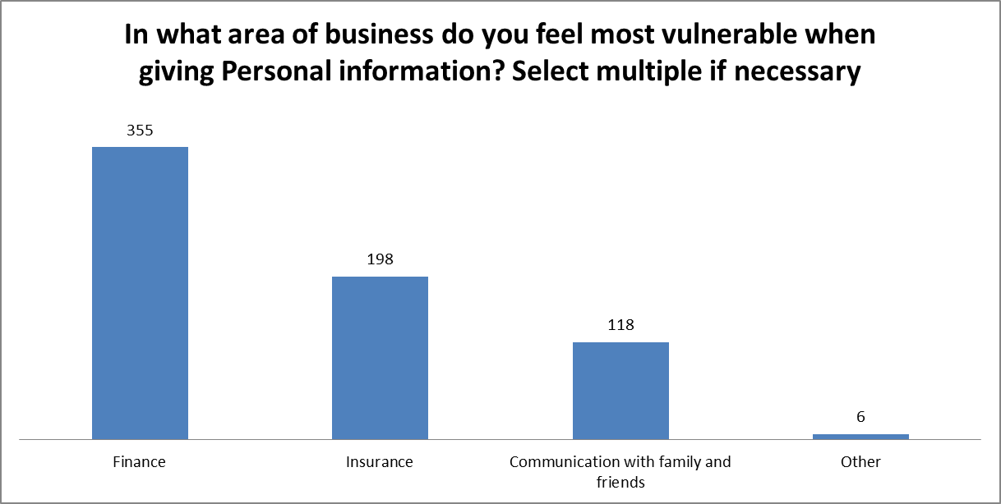

**Figure 14**

The chart above demonstrates the number of responses given for the area of business persons felt vulnerable. Three hundred fifty-five (355) said finance, one hundred ninety-eight (198) said insurance, one hundred eighteen (118) said through communication with family and friends, while the remaining six highlighted that they felt vulnerable either from purchasing item over the internet, applying for job online, phone tapping at work, western union transaction, conducting business on social media, and general purchases.

**Question 15**

**Figure 15**

The bar graph illustrates that 170 respondents prefer to be contacted by a phone call regarding their personal data, 132 indicated they prefer text message, 150 said they prefer email and 84 said other.

**Question 16**

**Figure 16**

The column chart shows that majority, 219 of the respondents would preferred to combat identity theft using automatic communication (SMS/Email). 190 of the respondents indicated they preferred to use biometrics and 127 said they preferred to use phone call to verify the individual.

**Question 17**

**Figure 17**

The column chart shows that 180 of the respondents said they would pay $1100-$2000 a month to a third party to protect their identity, 137 of the respondents was will to pay $600-$1000 a month, 133 respondents indicated that they would pay the third party $0-$500, 53 of the respondents said they would pay $3000-$6000 and 33 respondents indicated they would pay $7000-$10000.

**Question 18**

**Figure 18**

The pie chart shows that majority (62%) of the respondents fall in the age group 19-30, 15% in the range of 46-55, and 16% in the range of 31-45 while the remaining 7% was in the age group 56-65.

**Question 19**

**Figure 19**

The pie chart shows 57% of the respondents were males while the remaining 43% were female.

**Discussion**

The purpose of the study conducted was to determine the public’s perception on identity theft. It also sought to find out what methods of alleviating identity theft the public would be more receptive to. In conducting the research, the researchers aimed to answer the following research questions:

1. In what way does the government implement plans to combat identity theft in Jamaica?

2. What are the significant impacts of identity theft on the Jamaican citizens?

3. What are the perceptions of Identity theft by Jamaicans?

Responses provided from the questionnaire indicated that the significant ways in which

Jamaicans were affected by identity theft are money/cheque fraud, plastic card fraud, impersonation and stolen identification card/document. This is demonstrated in Figures 5 and 6. A study conducted by Langton and Planty (2010) the unauthorized misuse or attempted misuse of an existing credit card was the most prevalent type of identity theft among 53% of victims.

Identity theft may affect Jamaicans in a number of ways:

•*Their credit may be damaged* – When the thief runs up numerous charges in the victim’s name and does not pay the bill, it may be hard for the victim to apply for loans, credit cards and mortgages as their credit will be damaged.

•*Financial Loss* – One of the most devastating effects of identity theft is that of financial loss. For most identity theft victims, money that is lost is often never replaced. It was mentioned in the literature review that businesses also suffer from major financial implications. Banks in Jamaica lose millions of dollars annually due to cloning of credit and debit cards. It is also interesting to note that most respondents from the questionnaire felt most vulnerable in the area of finance when giving out personal information.

•*Criminal Record* – If an identity thief gives the victim’s name and personal information when he/she is arrested, the crime will go on the victim’s record.

The researchers found that more than half of the respondents (55%) did not think that identity theft was a major issue in Jamaica. The fact that 65% of respondents were not victims of identity theft (as shown in figure 3) could have contributed to that conclusion. It may prove to be problematic if Jamaicans are not aware that identity theft is a growing concern. More effort will have to be placed into informing the public that it is a major issue and that more methods needs to be put in place in order to minimize the occurrence of identity theft.

Based on the information provided by the respondents, a number of conclusions can be made:

•As shown in figure 7, most respondents (73%) believed that identity theft frequently occurs over the internet.

•Most respondents believe that something else needs to be done in order minimize the occurrence of identity theft. 71% of respondents felt that the government is not doing enough where identity theft is concerned.

•A database system has the potential to minimize the threat of identity theft and consumers will be receptive to this sort of preventative measure. Most respondents (70%) do not trust the government with their personal information and more than 50% of respondents are willing to use a third party to help protect their identities.

•Most respondents would prefer a system that uses automatic communication (SMS/email) to help combat identity theft.